**Aim: Configuring a Zone-Based Policy Firewall (ZPF)**

1. **The routers have been pre-configured with the following:**

**Console password:** conpa55

**Password for vty lines:** vtypa55

**Enable password:** enpa55

Host names and IP addressing

Local username and password: Admin / Adminpa55

Static routing

**Part 1: Verify Basic Network Connectivity:**

1. **Step 1: From the PC-A command prompt, ping PC-C at 192.168.3.3.**

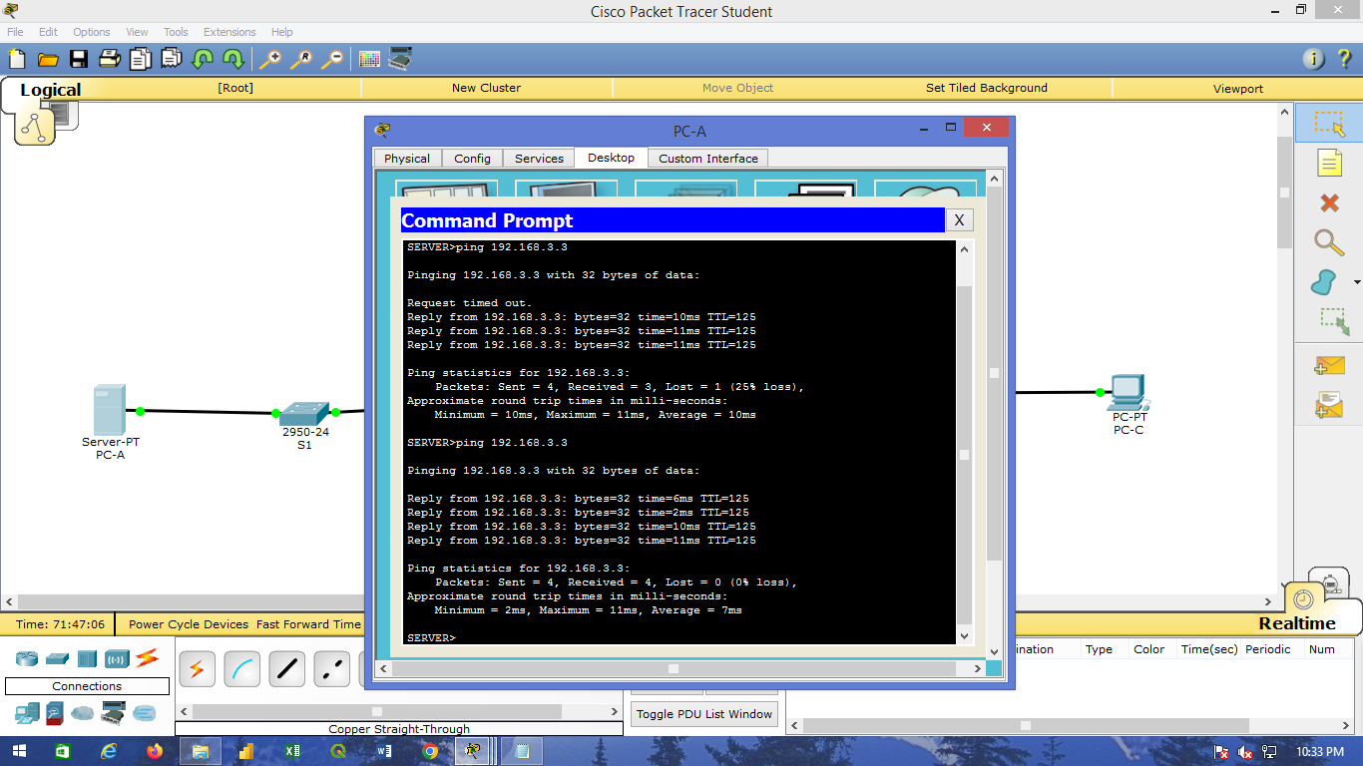

1. **Step 2:** **Access R2 using SSH.**
2. From the PC-C command prompt, SSH to the S0/0/1 interface on R2 at 10.2.2.2. Use the username Admin and password Adminpa55 to log in. PC> ssh -l Admin 10.2.2.2

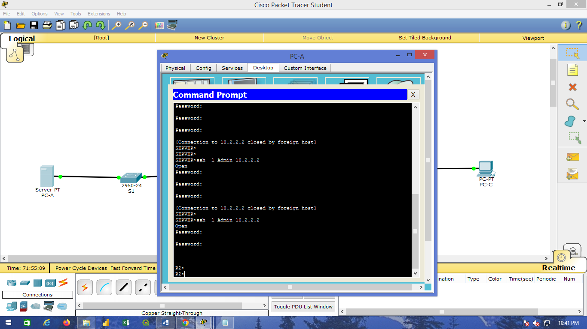

b) Exit the SSH session.

**3) Step 3: From PC-C, open a web browser to the PC-A server.**

a) Click the Desktop tab and then click the Web Browser application. Enter the PC-A IP address 192.168.1.3 as the URL. The Packet Tracer welcome page from the web server should be displayed. b. Close the browser on PC-C.

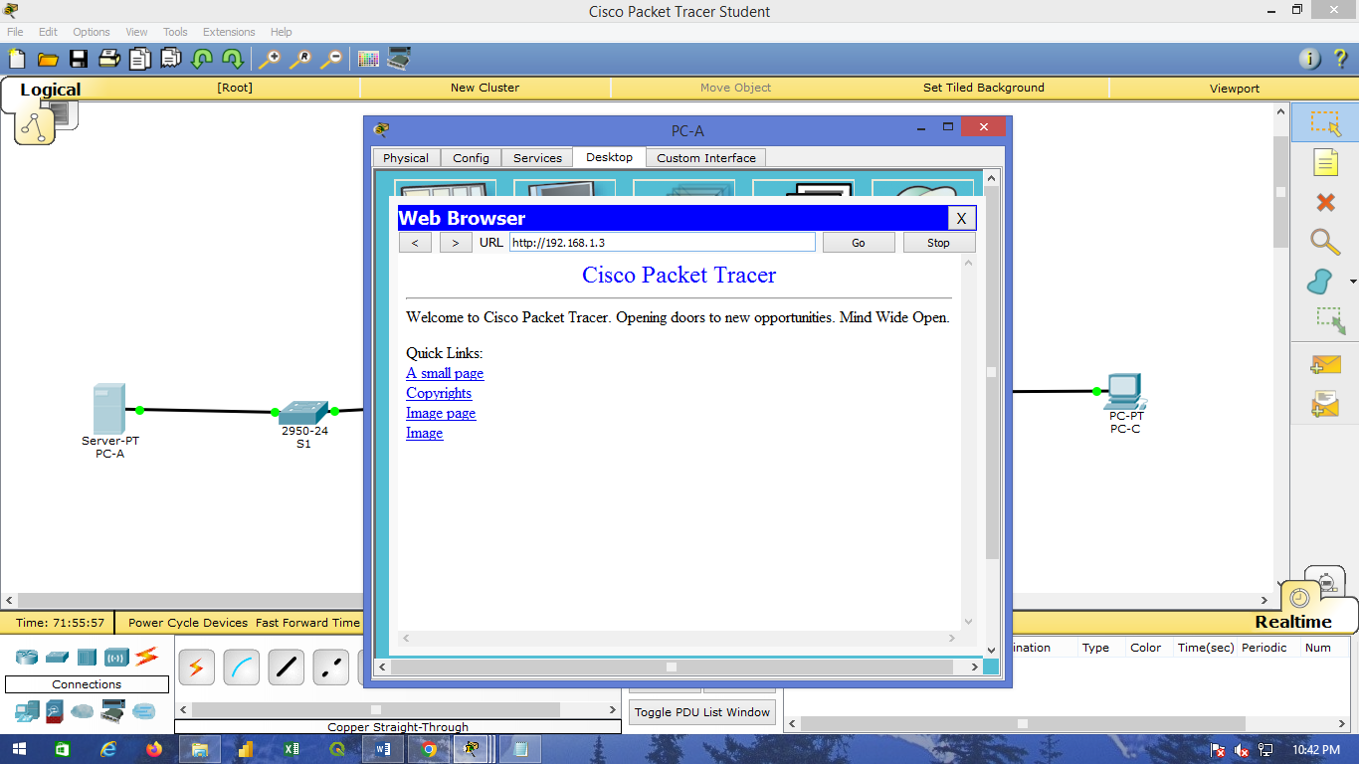

**Part 2: Create the Firewall Zones on R3:**

1. **Step 1: Enable the Security Technology package.**
2. On R3, issue the show version command to view the Technology Package license information.
3. If the Security Technology package has not been enabled, use the following command to enable the package. R3(config)# **license boot module c1900 technology-package securityk9**
4. Accept the end-user license agreement. d. Save the running-config and reload the router to enable the security license. e. Verify that the Security Technology package has been enabled by using the show version command.
5. **Step 2: Create an internal zone.** Use the zone security command to create a zone named IN-ZONE.

R3(config)# **zone security IN-ZONE R3(config-sec-zone) exit**

1. Step 3: Create an external zone. Use the zone security command to create a zone named OUT-ZONE.

R3(config-sec-zone)# **zone security OUT-ZONE**

R3(config-seczone)# **exit**

**Part 3: Identify Traffic Using a Class-Map:**

1. **Step 1: Create an ACL that defines internal traffic.**

Use the access-list command to create extended ACL 101 to permit all IP protocols from the 192.168.3.0/24 source network to any destination.

R3(config)# **access-list 101 permit ip 192.168.3.0 0.0.0.255 any**

1. **Step 2: Create a class map referencing the internal traffic ACL.**

Use the class-map type inspect command with the match-all option to create a class map named INNETCLASS-MAP. Use the match access-group command to match ACL 101.

R3(config)# **class-map type inspect match-all IN-NET-CLASS-MAP**

R3(config-cmap)# **match access-group 101**

R3(config-cmap)# **exit**

**Part 4: Specify Firewall Policies:**

1. **Step 1: Create a policy map to determine what to do with matched traffic.**

Use the policy-map type inspect command and create a policy map named IN-2-OUT-PMAP. R3(config)# **policy-map type inspect IN-2-OUT-PMAP**

1. **Step 2:** **Specify a class type of inspect and reference class map IN-NET-CLASS-MAP.**

R3(config-pmap)# **class type inspect IN-NET-CLASS-MAP**

1. Step 3: Specify the action of inspect for this policy map. The use of the inspect command invokes context-based access control (other options include pass and drop).

R3(config-pmap-c)# **inspect**

R3(config-pmap-c)# **exit**

R3(config-pmap)# **exit**

**Part 5: Apply Firewall Policies**

1. **Step 1: Create a pair of zones.**

Using the zone-pair security command, create a zone pair named IN-2-OUT-ZPAIR. Specify the source and destination zones that were created in Task 1.

R3(config)# **zone-pair security IN-2-OUT-ZPAIR source IN-ZONE destination OUTZONE**

1. **Step 2: Specify the policy map for handling the traffic between the two zones.**

Attach a policy-map and its associated actions to the zone pair using the service-policy type inspect command and reference the policy map previously created, IN-2-OUT-PMAP.

R3(config-sec-zone-pair)# **service-policy type inspect IN-2-OUT-PMAP**

R3(config-sec-zone-pair)# **exit**

1. **Step 3:** **Assign interfaces to the appropriate security zones.**

Use the zone-member security command in interface configuration mode to assign G0/1 to IN-ZONE and S0/0/1 to OUT-ZONE.

R3(config)# **interface g0/1**

R3(config-if)# **zone-member security IN-ZONE**

R3(config-if)# **exit**

R3(config)# **interface s0/0/1**

R3(config-if)# **zone-member security OUT-ZONE**

R3(config-if)# **exit**

1. **Step 4: Copy the running configuration to the startup configuration.**

**Part 6: Test Firewall Functionality from IN-ZONE to OUT-ZONE:**

1. **Step 1: From internal PC-C, ping the external PC-A server.**

From the PC-C command prompt, **ping PC-A at 192.168.1.3.** The ping should succeed.

1. **Step 2: From internal PC-C, SSH to the R2 S0/0/1 interface.**
2. From the PC-C command prompt, SSH to R2 at 10.2.2.2. Use the username Admin and the password Adminpa55 to access R2. The SSH session should succeed.
3. While the SSH session is active, issue the command show policy-map type inspect zone-pair sessions on R3 to view established sessions.
4. R3# **show policy-map type inspect zone-pair sessions**

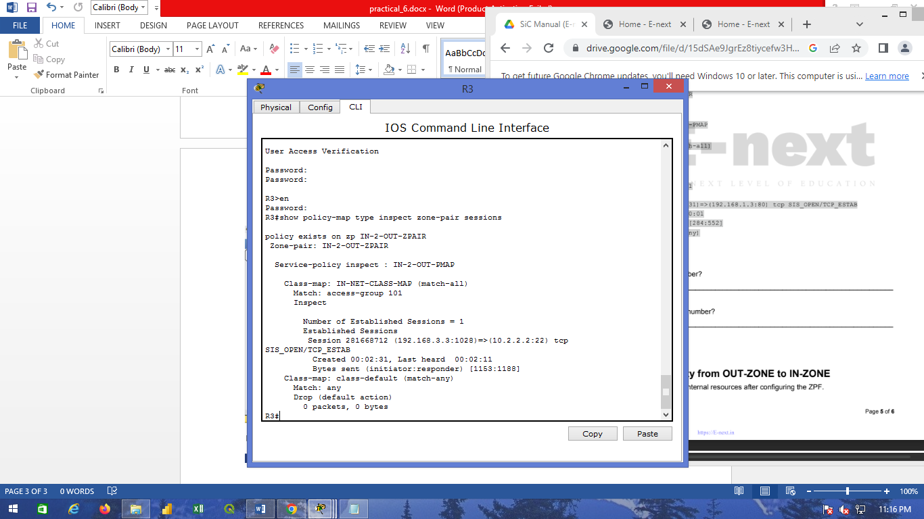

1. **Step 5: Close the browser on PC-C.**

**Part 7: Test Firewall Functionality from OUT-ZONE to IN-ZONE:**

1. **Step 1: From the PC-A server command prompt:**

ping PC-C. From the PC-A command prompt, ping PC-C at 192.168.3.3. The ping should fail.



1. **Step 2: From R2, ping PC-C.**

From R2, ping PC-C at 192.168.3.3. The ping should fail.

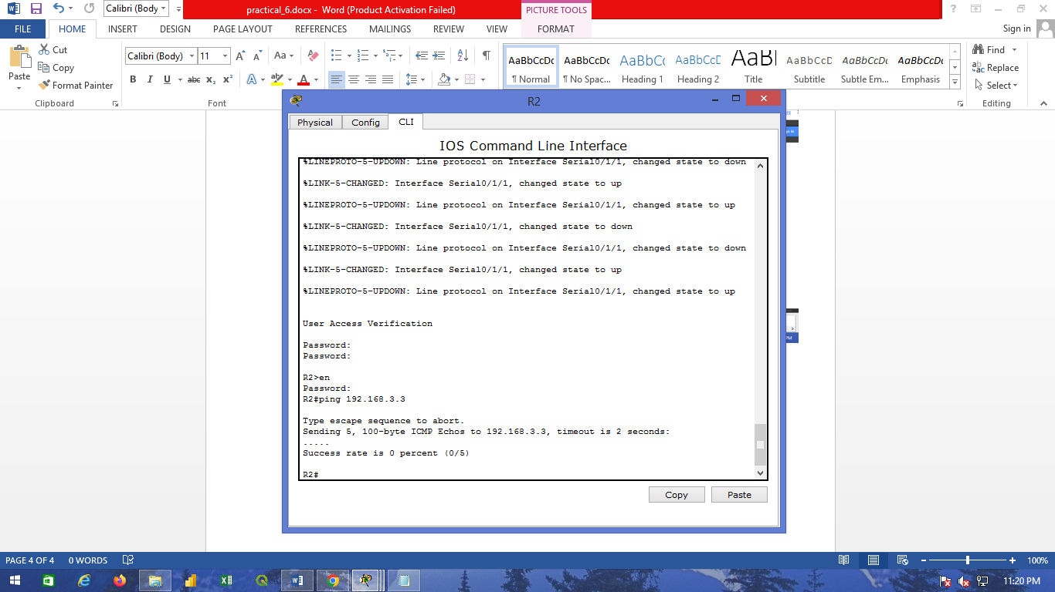

**Output:**

